

WORK ACROSS LOCAL GOVERNMENT & SCHOOLS


Join online at www.gmb.org.uk/join
June 2017
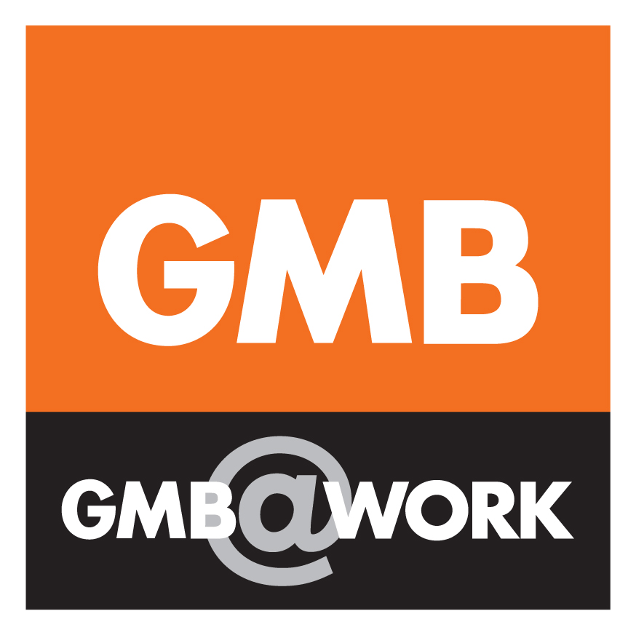

NJC TRADE UNIONS PRESENT PAY CLAIM TO LOCAL GOVERNMENT EMPLOYERS
Dear GMB Member
Thank you for taking part in the GMB NJC Pay consultation.
Following the GMB NJC Pay Consultation the GMB NJC Reps met on Tuesday 13/06/17. A detailed discussion took place with extensive report back on the regional pay consultations. The general consensus was to keep the NJC pay claim succinct for 2018/19.
Please note at the Conference the following GMB NJC Local Government Pay Claim was agreed. Headlines of the claim are as follows:
- 5% Increase on all NJC Pay Points
- The deletion of NJC pay points SCP 6-9 to reach the Resolution Foundation Living Wage of £8.45 (UK) and £9.75 (London)

All NJC Unions have agreed this pay claim and the NJC Pay claim has been presented to the Local Government Employers on Wednesday 14th June, 2017.
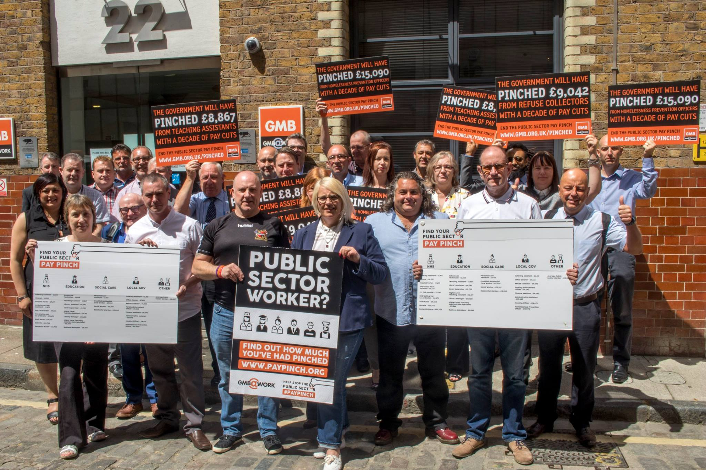

Full details of the claim are available from your local GMB Branch Office or GMB Office or email info@gmb.org.uk to request a copy.

Join the GMB Pay Pinch Campaign

Earlier this year the GMB launched a new national campaign calling for an end to pay restraint and to break the public sector pay cap.

When prices are rising twice as fast as wages, it’s time to call the Government’s 1% cap what it is – a severe cut to people’s quality of living.

Too many of our members in schools and local government have been struggling to make ends meet as they have seen real term pay cuts for over a decade.

The GMB’s new pay campaign says that enough is enough. Public sector workers deserve better.

That’s why we are calling on the Government to take the following steps:

- No ifs, no buts - an end to public sector pay restraint and cuts,
- Proper funding settlements so public services can remain high-quality and free at the point of use.
Full details of the campaign can be found at www.paypinch.org.uk

National Joint Council (NJC) Pay Claim 2018/19

Join online at www.gmb.org.uk/join

JOINT UNION PRESS RELEASE

Unions call for a long overdue pay rise for hard-pressed council employees
Three unions representing more than 1.6 million local government employees in schools and councils across England, Wales and Northern Ireland have today (Wednesday 14/06/17) submitted a pay claim that attempts to narrow the growing gap between declining wages and the rising cost of living.
The claim for the year from next April seeks to move the lowest paid staff onto the real living wage of £8.45 an hour (£9.75 in London).
In addition the unions want all employees to receive a five per cent pay rise.
The claim follows eight years of government-imposed pay restraint, which has seen wages either frozen or held to a one per cent increase.
GMB, Unison and Unite say that school and council employees’ living standards have plummeted as their wages have fallen way behind inflation.
Rehana Azam, GMB National Secretary for Public Services, said:
“Local government workers are suffering the worst squeeze on their pay in living memory, contributing to a public sector recruitment and retention crisis that is undermining the quality of services for everyone.
“Enough is enough. Our vital and under-appreciated staff must get a pay rise of at least five per cent to compensate for almost a decade of real-terms wage cuts. That is what they need and deserve.
“Last week’s election result was a clear vote for a new approach and against the running down of public services. It’s time for local government employers and Theresa May to listen.”
For Full Press Release: http://www.gmb.org.uk/newsroom/local-government-pay-claim

NEED HELP AT WORK? WE ONLY A CLICK AWAY – JOIN THE GMB
Joining the GMB is easy, quick and fast. You or your colleagues can join via one of the following methods:

- Online at www.gmb.org.uk/join

2. Complete the GMB application form
and simply post to FREEPOST G M B.
No other information is necessary.

- Ring 020 73916700.

- Email info@gmb.org.uk asking for a membership form.

- Ask the GMB to visit your workplace and work colleagues. Email info@gmb.org.uk and arrangements can be made to have a face to face meeting.

LET’S STICK TOGETHER TO WIN DECENT AND FAIR PAY TERMS AND CONDITIONS

Ensure your membership details are correct by registering with GMB online: https://www.gmb.org.uk/login

Why Join GMB?

GMB is Britain’s fastest growing trade union. GMB is a campaigning trade union; its job is to get the best deal for GMB members at work and is committed to building a strong organisation in every GMB workplace, and so help make every workplace safer. Whoever you are, wherever you work, joining GMB is the right decision.

GMB Membership Subscriptions:
1st October 2016 rates for GMB membership are:
Full time- Grade 1 = £3 per week (£13 per month)
Part time - Grade 2 = £1.75 per week (£7.58 per month)




